**LANGUAGE SECTION**

**A. Read the text below. Fill each gap in the text with the correct form of the verb in parentheses.**

Ten or twenty years ago, there was no online shopping. We 1. ___shopped________ (shop) for clothes, jewelry and shoes in real shops on downtown shopping streets. We spent hours walking from shop to shop, and it was never boring. Sometimes, we couldn’t find anything, but that 2. ___wasn’t ________ (be) a problem. We had fun anyway because we were spending time with our friends. When we were tired, we could go to a coffee shop to take a break from shopping.

Nowadays, our lives are very busy, and we 3. _don’t have_________ (have) time to go downtown with our friends or shop at real shops. We 4. ___usually shop________ (shop/usually) online. Online shopping is very fast and easy. We can find millions of products in online shops. Sometimes these products are cheaper than in real shops, too. However, online shopping also has problems. We 5. _______see___ (see) wonderful products on our computer screens, but we can’t try them on before we buy them. We 6. ___don’t spend_______ (spend) time with our friends, and we don’t relax together in a café while we’re shopping online. Does anyone ask you this when you’re shopping online?:

“Would you like a cup of coffee or tea?” No, they don’t. People 7. _sometimes say__________ (say/sometimes) that online shopping takes the fun out of shopping. I think they right. At the moment, I 8. ______am looking_____ (look) for shoes on a website, but I 9. ___don’t have________ (have) anyone to drink coffee with.

**B. Read the dialogue. Fill the gaps with ONE WORD ONLY.**

**Rob:** Jake hurt his leg, so he wants us to help him clean up his dorm room before his new roommate arrives.

**Karl:** So, Jake wants us to take *all* of (1) these books from his dorm room?

**Rob:** Yep, that’s right. Wow, I think this is the most crowded dorm room (2) in the world!

**Karl:** How (3) many books are there in his room, anyway?

**Rob:** Oh, he (4) has about 300 books, more or less.

**Karl:** There are a lot (5) of books, but there isn’t (6) any paper. That’s

good. So, where (7) are we taking them?

**Rob:** To his parents’ house. It’s not far away.

**Karl:** Hey, why don’t we throw (8) out his old things? I don’t think he wants this old

football any more.

**C. Complete the missing parts of the dialogue with ONE statement or question in each blank.**

**Travel Agent:** Hello, may I help you?

**Juliana:** Yes, please. I need to book a flight to Chicago.

(1) how much it costs, please?

**Travel Agent:** Certainly. A flight to Chicago costs about $550 for a return ticket.

(2)

**Juliana:** I’d like to leave at around 9 or 9:30 a.m. **Travel Agent:** OK, there’s a flight at 9:25. Is that OK? **Juliana:** That’s perfect, thanks.

**VOCABULARY SECTION**

**Fill each gap in the text with a word from the box. Use each word only ONCE. Be careful, there is ONE EXTRA WORD.**

**well-known according celebrate engine attracted prepare deep origin repeats tried length prevents luck**

The Duanwu Festival, also called the Dragon Boat Festival, is a very old festival in China. It is over 2,000 years old. Chinese people (1) it every year on the 5th day of the 5th month in the Chinese calendar. This is usually in June on the western calendar.

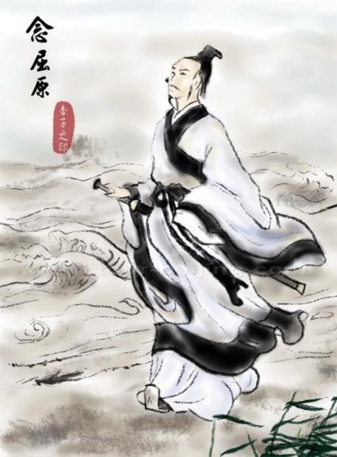

Chinese people say that the (2) of the festival is an event in history. There was a great Chinese poet and writer named Qu Yuan. Qu Yuan (3) _ to change China and make it a better place to live. The king didn’t like the changes, and told him to leave China. This made Qu Yuan very sad because he didn’t want to leave the land that he loved. Qu Yuan decided to kill himself, so he went into the (4) water of the Miluo River and

*drowned***\*** himself. During the Duanwu Festival, Chinese people remember Qu Yuan and how he loved China.

Today, during the Duanwu Festival, people (5) a

special food called zongzi. It has rice and vegetables or meat inside a bamboo leaf. When Qu Yuan killed himself in the river, people made zongzi and threw it into the water. The food (6) the attention of the fish, and they didn’t eat Qu Yuan’s body.

People also drink a special kind of wine during the festival. (7) to old Chinese beliefs, this wine cleans the blood. Chinese people think it also (8) illness and keeps them healthy. During the festival, people also make small bags and fill them with perfume or medicine. They wear these bags on a string around their neck, and say that the bags bring good

(9) and protect them from bad spirits.

Dragon boat racing is a / an (10) and very popular activity during the Duanwu Festival. Groups of people race long, narrow boats in the water. The (11) of each boat is different: some boats are longer, and some are shorter. The boats don’t have

a / an (12) , so the people use oars to push the boats through the water. There is also a drummer on each boat, and the people

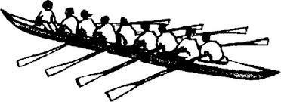

move the oars together with the drum’s sound. The Chinese people say that after Qu Yuan went into the river, people went out in

boats like this to save him.

**\****to drown*: to die by breathing water

**a boat with oars**

**READING SECTION Text I**

**Read the text, and answer the questions that follow.**

**Backpacking Cuckoos**

People all over Europe know the cuckoo bird from its

sound. It doesn't sing, but it makes a noise with one high note and one low note – 'coo coo'. When people in Europe hear a cuckoo for the first time each year, they know that

**5** spring is here. In some years, people hear cuckoos in February. That is very early. In other years, they don't arrive until April. Usually, the birds arrive in March. This is because the cuckoo lives in Africa during the winter months. It only comes to Europe when the weather gets warmer there.

**10** People have always known that cuckoos *migrate****\****. They fly thousands of miles across the Sahara desert twice a year – in

***CHART 1***

the spring, and in the summer, usually at the end of July. In August, there are not many cuckoos left in Europe.

In the past, scientists didn’t know how cuckoos made their long and

**15** difficult journey. However, now, a new kind of technology allows scientists to follow **this species** and see where they go during their journey to Africa and back.

In May 2011, scientists caught five male birds in Norfolk in eastern

England. They put a very small GPS tag on each one’s back, and then

**20** set it free again. The tags allowed the scientists to see where the birds went after they left England. The scientists found that the five birds each travelled about 10,000 miles that summer, and they all spent the winter in the Congo region of central Africa. However, the scientists were surprised by what they found: each bird took a

**25** different route (way of travelling) to its winter home in Africa. The first bird, named Lyster, flew across France, Spain and Morocco before he crossed the Sahara desert. The second bird, Chris, went by a completely different route. **He** flew over Belgium, Germany and

Italy before he crossed the Sahara desert in Libya. The other three

**30** birds flew over Tunisia and Algeria on their way to Africa.

The scientists also saw that all five birds left Africa again, nine months later, to come back to Britain. Amazingly, they each took a different route again. They took different routes from each other, but they also took a different route from their first route. For example, Lyster flew back to England over

**35** Algeria and France; this time, he didn't fly over Spain and Morocco. Chris also crossed the Algerian desert, but then continued his journey over Italy and France. The two birds, however, both returned to the same place in Norfolk where they got their GPS tags the year before. The three other

birds did not return to England, and the scientists think they died on their

**40** return journey.

Congo

***CHART 2***

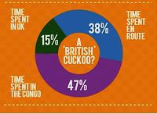

**The amount of time that Chris, one of the cuckoos, spent in Britain, in the Congo, and *en route* (flying between the two places)**

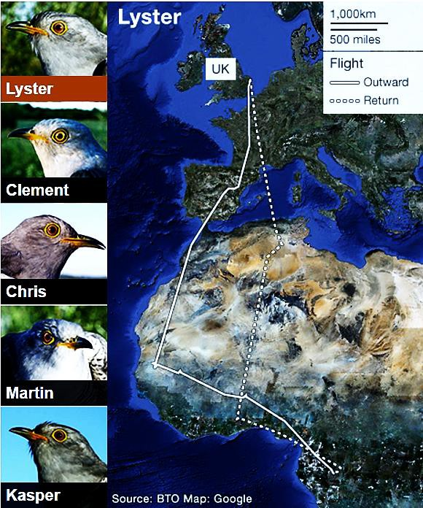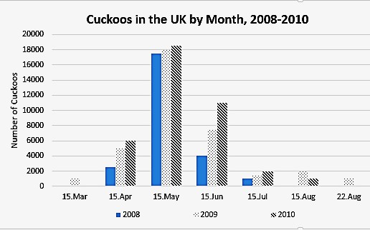

**7**

**A. Answer the questions True (T), False (F) or No Information (NI) according to Charts 1 and 2. (1 pt. each; 4 pts.)**

**T F NI** 1. Between 2008 and 2010, the first cuckoos arrived in the UK in April.

**T F NI** 2. In 2010, the UK had the largest number of cuckoos in the month of May.

**T F NI** 3. The cuckoo named Chris spent 20% of his time flying over the Sahara desert.

**T F NI** 4. Chris spent the largest amount of his time in the UK.

**B. What do the following words in the text refer to?**

1. “this species” (line 17) :

2. “He” (line 30) :

**C. Answer the following questions according to the text and the pictures.**

1. When do people in Europe know that spring is here?

.

2. Where do cuckoos spend the winter?

a) in Europe b) in Asia

c) in Africa

d) in South America

3. How often do cuckoos fly across the Sahara desert?

_.

4. How did the GPS tags help the scientists?

.

5. What surprised the scientists about the birds’ migration routes?

_.

6. How was Lyster’s flight back to England different from his flight to the Congo?

.

7. What happened to Clement, Martin and Kasper?

.

**Text II**

**Read the text, and answer the questions that follow. Eco Escapes: Cycling Holidays**

Are you worried about the amount of *pollution***\*** you cause when you go on holiday? Both public

transport and cars can cause pollution in places with a lot of tourists. Travelling by plane, train or bus

also causes pollution. Some people think that this is wrong, so many people are choosing a different type of holiday these days. Cycling holidays are greener than holidays by car, train or plane, and you get a lot

**5** of good exercise, too. With cycling holidays, you can have a break and see different places, and you can keep fit at the same time.

***Who organises cycling holidays?***

There are different ways of organising a cycling holiday. You can go alone if you want, but sometimes, groups of people plan their trip together before they go, and **this** often makes the holiday more fun. You

**10** can also book a holiday with a tour company. The company organises the trip before you go so that you have no worries. On this type of holiday, you also have the chance to make friends with the other people on the trip.

***How far can I cycle?***

There are different types of cycling holiday. Serious cyclists sometimes want to travel a long distance

**15** every day, because for them, the enjoyment of cycling fast is part of the fun of the holiday. Other people prefer to see the scenery and look around the places they pass through, so they are happy to travel more slowly. You can decide the distance you want to go every day, and most holiday companies offer a lot of different trips for different types of customer.

***How fit should I be?***

**20** Many people on cycling holidays choose this type of holiday because they know that they enjoy cycling.

If you aren’t a regular cyclist, or if you only rode a bike when you were a child, then you should do some training before your trip. You don’t need to be very strong to ride a bike, but you should be healthy. Cycling in places with a lot of hills, such as Scotland, will give you a good workout. But if that sounds difficult, you should choose an area like East Anglia, with flat roads.

**25 *Where do I sleep on a cycling holiday?***

There are also a lot of options for places to sleep while you are on your trip. Some people prefer a

'center-based' cycling holiday, for example, where you return to the same hotel every evening and have a good meal and a shower. Others prefer to follow a long route and sleep in a different place each night. They sometimes carry a tent with them so that they can camp.

**30 *What should I take with me when I’m cycling?***

Clearly, it is not a good idea to cycle with a lot of luggage. Holiday companies sometimes send your suitcases to your next **destination** so that they are waiting there for you when you arrive in the evening. This means that you only need to carry a few things with you every day. It’s a good idea to have some different types of clothing because the weather can change very quickly. It’s also very important to take

**35** a good map or GPS, and an emergency repair kit for your bike.

***Are cycling holidays expensive?***

Some cycling holidays are more expensive than others. If you want to cycle in another country, then you have to travel **there** before you can start cycling, and that may be expensive. However, camping is a

good way to spend less money on your cycling holiday. Generally speaking, you can find a cycling holiday

**40** to suit any budget.

**A. What do the following words in the text refer to?**

1. ‘this’ on line 9 refers to **the fact that people** _. a) go on a cycling holiday alone

b) plan their trip with a group of friends

c) book a holiday with a tour company

d) make friends with other people on the trip

2. ‘there’ on line 38 refers to : _.

**B. Guess the meaning of the following word in the text.**

1. The word ‘destination’ on line 32 probably means . a) resting-place

b) flight

c) invention d) speed

**C. Answer the following questions according to the text.**

1. Write two advantages of cycling holidays according to the first paragraph.

a) _. b) _.

2. What two options are there for sleeping on your cycling trip?

a)

b)

3. Write one thing you should carry with you on a cycling trip.

_.

**D. Complete the sentences according to the information in paragraphs 3 and 4. DO NOT write more than 4 words.**

*Paragraph 3*

Serious cyclists enjoy (1) on their holiday, so they travel

(2) every day. Other people go more slowly because

they want to (3) (4)

and they pass through.

*Paragraph 4*

You should (5) before your trip if you aren’t fit or if you don’t ride a bike very often. You should be (6a) if you want to ride a bike, but you don’t have to be (6b) . If you don’t want to have a workout, ride in a

place with flat roads, such as (7) .

**ANSWER KEY**

**A.**

1. shopped
2. wasn’t
3. don’t have
4. usually shop
5. see
6. don’t spend
7. sometimes say
8. am looking
9. don’t have

**B.**

1. the / his / these

2. in

3. many

4. has / owns

5. of

6. much / any

7. are

8. away / out

**C.**

1. Could / Can / Will / Would you tell me

2. What time would you like / do you want to leave?

When would you like / do you want to leave?

**VOCABULARY SECTION**

1. celebrate

2. origin

3. tried

4. deep

5. prepare

6. attracted

7. According

8. prevents

9. luck

10. well-known

11. length

12. engine

**READING SECTION Text I**

**A.**

1. F 2. T 3. NI 4. F

**B.**

**Capitalization / Copying / Spelling mistakes: C&A**

1. (the) cuckoo

2. Chris / (The) second bird

**C.**

1. When they / people in Europe hear a cuckoo for the first time each year.

2. c

3. Twice a year (– in the spring, and in the summer)

4. They allowed / helped them to see where the birds went after they left England

5. (The fact that) each bird took a different route (to its winter home in Africa)

6. He / Lyster flew back to England over Algeria and France

7. (The scientists think) they died (on their return journey)

**Text II**

**A.**

1. b

2. to another / a / the country

**B.**

1. a

**C.**

1.

Cycling holidays / They are greener (than holidays by car, train or plane **/** ordinary holidays) You get (a lot of good) exercise / keep fit

You can have a break and see different places

2.

a) (stay(ing) / sleep(ing) in a) hotel

return(ing) to the same hotel each / every evening

b) (sleep(ing) in a) tent

sleep(ing) in a different place each / every night

3. (Some) different types of clothing

(A) good map / GPS

(An)(emergency) repair kit (for your bike)

**D.**

1. cycling fast

2. a long distance

3. see the scenery

4. look around the places

5. do some training

6.

a) healthy

b) (very) strong

7. East Anglia

**13**